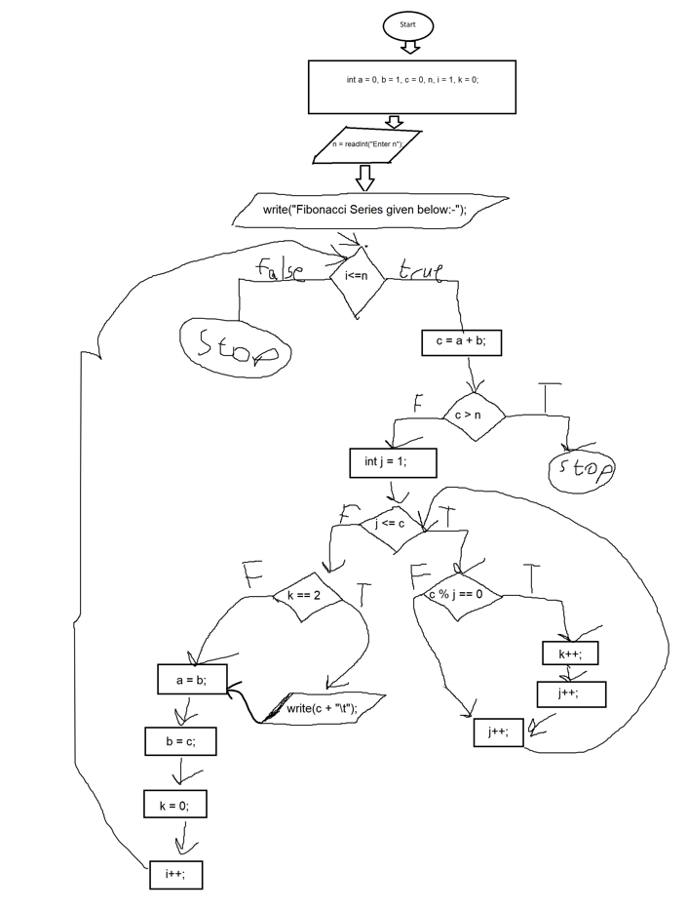

|  |  |  |  |  |  |  |  |
| --- | --- | --- | --- | --- | --- | --- | --- |
| Line | a | b | c | n | i | k | j |
| 3 | 0 | 1 | 0 | - | 1 | 0 | - |
| 4 | 0 | 1 | 0 | 30 | 1 | 0 | - |
| 7 | 0 | 1 | 1 | 30 | 1 | 0 | - |
| 11 | 0 | 1 | 1 | 30 | 1 | 0 | 1 |
| 14 | 0 | 1 | 1 | 30 | 1 | 1 | 1 |
| 15 | 0 | 1 | 1 | 30 | 1 | 1 | 2 |
| 17 | 0 | 1 | 1 | 30 | 1 | 1 | 3 |
| 22 | 1 | 1 | 1 | 30 | 1 | 1 | 3 |
| 23 | 1 | 1 | 1 | 30 | 1 | 1 | 3 |
| 24 | 1 | 1 | 1 | 30 | 1 | 0 | 3 |
| 26 | 1 | 1 | 1 | 30 | 2 | 0 | 3 |
| 7 | 1 | 1 | 2 | 30 | 2 | 0 | 3 |
| 11 | 1 | 1 | 2 | 30 | 2 | 0 | 1 |
| 17 | 1 | 1 | 2 | 30 | 2 | 0 | 2 |
| 14 | 1 | 1 | 2 | 30 | 2 | 1 | 2 |
| 15 | 1 | 1 | 2 | 30 | 2 | 1 | 3 |
| 17 | 1 | 1 | 2 | 30 | 2 | 1 | 4 |
| 22 | 1 | 1 | 2 | 30 | 2 | 0 | 2 |
| 23 | 1 | 2 | 2 | 30 | 2 | 0 | 2 |
| 24 | 1 | 2 | 2 | 30 | 2 | 0 | 2 |
| 26 | 1 | 2 | 2 | 30 | 3 | 0 | 2 |
| 7 | 1 | 2 | 3 | 30 | 3 | 0 | 2 |
| 11 | 1 | 2 | 3 | 30 | 3 | 0 | 1 |
| 14 | 1 | 2 | 3 | 30 | 3 | 1 | 1 |
| 15 | 1 | 2 | 3 | 30 | 3 | 1 | 2 |
| 17 | 1 | 2 | 3 | 30 | 3 | 1 | 3 |
| 14 | 1 | 2 | 3 | 30 | 3 | 2 | 3 |
| 15 | 1 | 2 | 3 | 30 | 3 | 2 | 4 |
| 17 | 1 | 2 | 3 | 30 | 3 | 2 | 5 |
| 22 | 2 | 2 | 3 | 30 | 3 | 2 | 5 |
| 23 | 2 | 3 | 3 | 30 | 3 | 2 | 5 |
| 24 | 2 | 3 | 3 | 30 | 3 | 0 | 5 |
| 26 | 2 | 3 | 3 | 30 | 4 | 0 | 5 |
| 7 | 2 | 3 | 5 | 30 | 4 | 0 | 5 |
| 11 | 2 | 3 | 5 | 30 | 4 | 0 | 1 |
| 14 | 2 | 3 | 5 | 30 | 4 | 1 | 1 |
| 15 | 2 | 3 | 5 | 30 | 4 | 1 | 2 |
| 17 | 2 | 3 | 5 | 30 | 4 | 1 | 3 |
| 17 | 2 | 3 | 5 | 30 | 4 | 1 | 4 |
| 17 | 2 | 3 | 5 | 30 | 4 | 1 | 5 |
| 14 | 2 | 3 | 5 | 30 | 4 | 2 | 5 |
| 15 | 2 | 3 | 5 | 30 | 4 | 2 | 6 |
| 17 | 2 | 3 | 5 | 30 | 4 | 2 | 7 |
| 22 | 3 | 3 | 5 | 30 | 4 | 2 | 7 |
| 23 | 3 | 5 | 5 | 30 | 4 | 2 | 7 |
| 24 | 3 | 5 | 5 | 30 | 4 | 0 | 7 |
| 26 | 3 | 5 | 5 | 30 | 5 | 0 | 7 |
| 7 | 3 | 5 | 8 | 30 | 5 | 0 | 7 |
| 11 | 3 | 5 | 8 | 30 | 5 | 0 | 1 |
| 14 | 3 | 5 | 8 | 30 | 5 | 1 | 1 |
| 15 | 3 | 5 | 8 | 30 | 5 | 1 | 2 |
| 17 | 3 | 5 | 8 | 30 | 5 | 1 | 3 |
| 17 | 3 | 5 | 8 | 30 | 5 | 1 | 4 |
| 14 | 3 | 5 | 8 | 30 | 5 | 2 | 4 |
| 15 | 3 | 5 | 8 | 30 | 5 | 2 | 5 |
| 17 | 3 | 5 | 8 | 30 | 5 | 2 | 6 |
| 17 | 3 | 5 | 8 | 30 | 5 | 2 | 7 |
| 17 | 3 | 5 | 8 | 30 | 5 | 2 | 8 |
| 14 | 3 | 5 | 8 | 30 | 5 | 3 | 8 |
| 15 | 3 | 5 | 8 | 30 | 5 | 3 | 9 |
| 17 | 3 | 5 | 8 | 30 | 5 | 3 | 10 |
| 22 | 5 | 5 | 8 | 30 | 5 | 3 | 10 |
| 23 | 5 | 8 | 8 | 30 | 5 | 3 | 10 |
| 24 | 5 | 8 | 8 | 30 | 5 | 0 | 10 |
| 26 | 5 | 8 | 8 | 30 | 6 | 0 | 10 |
| 7 | 5 | 8 | 13 | 30 | 6 | 0 | 10 |
| 11 | 5 | 8 | 13 | 30 | 6 | 0 | 1 |
| 14 | 5 | 8 | 13 | 30 | 6 | 1 | 1 |
| 15 | 5 | 8 | 13 | 30 | 6 | 1 | 2 |
| 17 | 5 | 8 | 13 | 30 | 6 | 1 | 3 |
| 17 | 5 | 8 | 13 | 30 | 6 | 1 | 4 |
| 17 | 5 | 8 | 13 | 30 | 6 | 1 | 5 |
| 17 | 5 | 8 | 13 | 30 | 6 | 1 | 6 |
| 17 | 5 | 8 | 13 | 30 | 6 | 1 | 7 |
| 17 | 5 | 8 | 13 | 30 | 6 | 1 | 8 |
| 17 | 5 | 8 | 13 | 30 | 6 | 1 | 9 |
| 17 | 5 | 8 | 13 | 30 | 6 | 1 | 10 |
| 17 | 5 | 8 | 13 | 30 | 6 | 1 | 11 |
| 17 | 5 | 8 | 13 | 30 | 6 | 1 | 12 |
| 17 | 5 | 8 | 13 | 30 | 6 | 1 | 13 |
| 14 | 5 | 8 | 13 | 30 | 6 | 2 | 13 |
| 15 | 5 | 8 | 13 | 30 | 6 | 2 | 14 |
| 17 | 5 | 8 | 13 | 30 | 6 | 2 | 15 |
| 22 | 8 | 8 | 13 | 30 | 6 | 2 | 15 |
| 23 | 8 | 13 | 13 | 30 | 6 | 2 | 15 |
| 24 | 8 | 13 | 13 | 30 | 6 | 0 | 15 |
| 26 | 8 | 13 | 13 | 30 | 7 | 0 | 15 |
| 7 | 8 | 13 | 21 | 30 | 7 | 0 | 15 |
| 11 | 8 | 13 | 21 | 30 | 7 | 0 | 1 |
| 14 | 8 | 13 | 21 | 30 | 7 | 1 | 1 |
| 15 | 8 | 13 | 21 | 30 | 7 | 1 | 2 |
| 17 | 8 | 13 | 21 | 30 | 7 | 1 | 3 |
| 14 | 8 | 13 | 21 | 30 | 7 | 2 | 3 |
| 15 | 8 | 13 | 21 | 30 | 7 | 2 | 4 |
| 17 | 8 | 13 | 21 | 30 | 7 | 2 | 5 |
| 17 | 8 | 13 | 21 | 30 | 7 | 2 | 6 |
| 17 | 8 | 13 | 21 | 30 | 7 | 2 | 7 |
| 14 | 8 | 13 | 21 | 30 | 7 | 3 | 7 |
| 15 | 8 | 13 | 21 | 30 | 7 | 3 | 8 |
| 17 | 8 | 13 | 21 | 30 | 7 | 3 | 9 |
| 17 | 8 | 13 | 21 | 30 | 7 | 3 | 10 |
| 17 | 8 | 13 | 21 | 30 | 7 | 3 | 11 |
| 17 | 8 | 13 | 21 | 30 | 7 | 3 | 12 |
| 17 | 8 | 13 | 21 | 30 | 7 | 3 | 13 |
| 17 | 8 | 13 | 21 | 30 | 7 | 3 | 14 |
| 17 | 8 | 13 | 21 | 30 | 7 | 3 | 15 |
| 17 | 8 | 13 | 21 | 30 | 7 | 3 | 16 |
| 17 | 8 | 13 | 21 | 30 | 7 | 3 | 17 |
| 17 | 8 | 13 | 21 | 30 | 7 | 3 | 18 |
| 17 | 8 | 13 | 21 | 30 | 7 | 3 | 19 |
| 17 | 8 | 13 | 21 | 30 | 7 | 3 | 20 |
| 17 | 8 | 13 | 21 | 30 | 7 | 3 | 21 |
| 14 | 8 | 13 | 21 | 30 | 7 | 4 | 21 |
| 15 | 8 | 13 | 21 | 30 | 7 | 4 | 22 |
| 17 | 8 | 13 | 21 | 30 | 7 | 4 | 23 |
| 22 | 13 | 13 | 21 | 30 | 7 | 4 | 23 |
| 23 | 13 | 21 | 21 | 30 | 7 | 4 | 23 |
| 24 | 13 | 21 | 21 | 30 | 7 | 0 | 23 |
| 26 | 13 | 21 | 21 | 30 | 8 | 0 | 23 |
| 7 | 13 | 21 | 34 | 30 | 8 | 0 | 23 |
| 9 (BREAK) |  |  |  |  |  |  |  |